# A

**MINI PROJECT REPORT ON**

# “Super Mart Software (SMS)”

**OF**

# MASTER OF COMPUTER APPLICATIONS (MCA)

**SUBMITTED BY**

# (Somani Suraj Manoj)

**UNDER THE GUIDANCE OF**

# (Prof. Gayatri Asalkar)

**TO**

## SAVITRIBAI PHULE PUNE UNIVERSITY

**DR. D.Y. PATIL CENTRE FOR MANAGEMENT & RESEARCH, CHIKHALI, PUNE-411062**

# 2022-2023

CERTIFICATE

This is to certify that Mr. **SURAJ MANOJ SOMANI** is student of MCA 1st Year full time degree course at our Institute. His/ Her MINI PROJECT WORK TITLED **"SUPER MART SOFTWARE"** submitted as part of the curriculum for the award of Master of Computer Application degree of Savitribai Phule Pune University, Pune. This is an original work done by him. This work is not submitted earlier in part or full to this or any other institute / University for any degree / diploma.

|  |  |  |
| --- | --- | --- |
| **Project Guide** | **HOD** | **Director** |
| **DYPCMR** | **DYPCMR** | **DYPCMR** |

(Prof. Gayatri Asalkar) (Prof. Minal Pawar) (Dr. Sunil Dhanwade)

Place: Chikhali, pune Date: 18th march 2023

# ACKNOWLEDGEMENT

My sincere thanks to our Director Sir **Dr. Sunil Dhanawade** and HOD **Prof. Minal Pawar** without whose guidance, ideas and time to time help to this project would not have been completed. I would never got this exhilarating sense of accomplishment without his guidance. Especially I thank my project guide **Prof. Gayatri Asalkar** faculty of **S. M. Dr. D. Y. Patil Center for Management and Research, Chikhali, Pune** for her valuable guidance, co-operations and encouragement throughout the project.

Date: 18th march 2023 Signature

Place: Chikhali, pune **Suraj Somani**

# INDEX

|  |  |  |
| --- | --- | --- |
| **Sr. No** | **Contents** | **Page**  **No** |
|  | | |
| **Ch. 01** | **Introduction** | **05** |
| 1.1 | Existing System And Need For System. | 05 |
| 1.2 | Scope Of Work. | 06 |
| 1.3 | Operating Environment – Hardware And Software. | 07 |
| 1.4 | Detail Description Of Technology Used. | 08 |
| **Ch. 02** | **Proposed System** | **10** |
| 2.1 | Proposed System. | 10 |
| 2.2 | Objectives Of System. | 11 |
| 2.3 | User Requirements. | 11 |
| **Ch. 03** | **System Analysis** | **12** |
| 3.1 | Use Case Diagram | 12 |
| 3.2 | Class Diagram | 13 |
| 3.3 | ER Diagram | 14 |
| 3.4 | Activity Diagram | 15 |
| 3.5 | Sequence Diagram | 16 |
| **Ch. 04** | **System Design** | **17** |
| 4.1 | User Interface Design (Screens, Reports, Etc.) | 17 |
| 4.2 | Data Dictionary | 30 |
| **Ch. 05** | **Report Testing** | **32** |
| **Ch. 06** | **Limitations and Conclusions** | **34** |
| **Ch. 07** | **Bibliography** | **36** |

**INTRODUCTION**

Super Mart Software (SMS) is a standalone system that helps the owners of Super Mart to manage the data ands information of their super mart. It provides the solution for replacing the manual work done to manage the daily records of super marts. A full-featured application is needed for mart to manage all the stored data and information systematically and efficiently. SMS application is developed for mini marts to manage inventory, staff, supplier and finance records. In the SMS application, monthly profit can be calculated and therefore monthly or yearly sales analysis can be performed.

## Existing System & Need for System: -

Unfortunately, don't have any kind of existing system. Managing the information is actually not an easy task because of course it’s Information. The data of which is being available in a very big quantity is being maintained by humans ( paper work / documents) only they have to jot down all the data, information, records, etc. in to the documents.

This process not only take time but also this process is very hard and difficult to maintain because one calculation or mistake into the records leads up to a very huge loss. Not only this, if any single document is lost or damage, then also there will be big problem for the inventory.

## Scope of Work: -

Scope of supermarket tends to the future of the supermarket business. As it follows a particular model, supermarkets should not mix up with the norms of the traditional market. All the component entities that are being mentioned must be taken care of while successfully managing the supermarket business:

* The retail store chain.
* Transportation systems.
* Number of retail stores in a particular area.
* Product suppliers on a regional basis.

|  |  |  |  |
| --- | --- | --- | --- |
| **1.3.**  ▪ | **Operating Environment: -**  **Hardware Requirements: -** |  | |
|  | * Processor | ➔ | Intel Core i3. |
|  | * Hard Disk * RAM | ➔  ➔ | 512 GB.  04 GB. |

## Software Requirements: -

|  |  |  |  |
| --- | --- | --- | --- |
| * Operating | System | ➔ | Windows 7 or later, macOS, Linux. |
| * Frontend * Backend |  | ➔  ➔ | Java (GUI with Swing).  MySQL. |

* + Tools / IDE’s ➔ Apache NetBeans.

## 1.4. Detailed Description of Technology Used: -

Swing is a Java Foundation Classes [JFC] library and an extension of the Abstract Window Toolkit [AWT]. Swing offers much-improved functionality over AWT, new components, expanded components features, and excellent event handling with drag-and-drop support.

Swing has about four times the number of User Interface [UI] components as AWT and is part of the standard Java distribution. By today’s application GUI requirements, AWT is a limited implementation, not quite capable of providing the components required for developing complex GUIs required in modern commercial applications.

Many programmers think that JFC and Swing are one and the same thing, but that is not so.

JFC contains Swing [A UI component package] and quite a number of other items:

* Cut and paste: Clipboard support.
* Accessibility features: Aimed at developing GUIs for users with disabilities.
* The Desktop Colors Features Has been Firstly introduced in Java 1.1.
* Java 2D: it has Improved colors, images, and also texts support.

### Features Of Swing Class: -

* Pluggable look and feel.
* Uses MVC architecture.
* Lightweight Components.
* Platform Independent.
* Advanced features such as JTable, JTabbedPane, JScollPane, etc.
* Pluggable Look and Feel.
* Lightweight Components.
* Highly customizable.
* Rich controls

# PROPOSED SYSTEM

## Proposed System: -

So far, thus we have proposed such a system in which one needs to enter all the details into the computer and then all the collection of details and inventory will get saved automatically. In fact, the calculations do not require any manual work. You just need to have enter the amount and the quantity, and as per the program everything will get calculated in just a single minute and will automatically get saved into the database. In case, if one copy of the data is being lost, then due to this highly programmed software, the backup of all the data is being available into the database from where, the authorized person can get access to the lost data once again.

## Objectives of System: -

The Super Mart Software is a highly programmed software whose task is to maintain and keep track of all the records of the goods that are available in stock or is not available too in an inventory management system.

As we all know, Inventory is basically a place where all the retail things and various goods and items are stored and maintained and is sell to the buyers. When a good is sell, all the details like to which retailer the good is being selling or which item and how many in quantity and at what prices are being it is selling. All the details is being managed in the Super Mart Software.

## User Requirements: -

* Processor: - Intel Core i3 or above.
* RAM: - 4 GB.
* Operating System: - Windows 7 or later, macOS, Linux.
* User must have knowledge about How to use Computer or Laptop.
  1. **Use Case Diagram**

# SYSTEM ANALYSIS

**Admin**

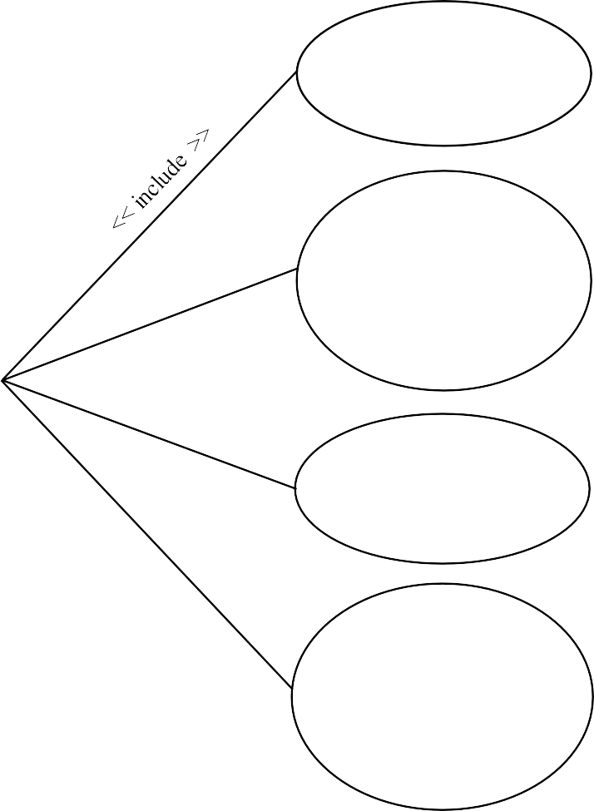

Login

Manages

Employee Payroll

Manage

Stock

Control Over

Sales

Prints

Report

Print Sales

Receipt

System Boundary

* 1. **Class Diagram**

|  |
| --- |
| **Admin** |
| **+** user_name : String  + password : String |
| +Login() |

* Prints

Manages

•

### Employees

* ID : Integer
* name : String
* contact : Integer
* gender : String
* age : Integer

### Stock

* product_ID : Integer
* Product_name : String
* Entry_date : date

+ available_stock()

+ employee_details()

### Report

Manages

•

### Sales

* + ID : Integer
  + name : String
* product_ID : Integer
* Product_name : String
* Entry_date : date
* quantity : Integer

+ sales_receipt()

+ report()

## ER Diagram

UserName

Password

Admin

1

Prints

1

1 1

Name

Has

Id

Contact M

Employees

Report

M

Age

Salary

Manages

ID

Name

M

Sales

Quantity

Product_ID M

Quantity

Stock

Super Mart Software

Product_Name

Entry_Date

Price

14

## Activity Diagram

Initial Stage

Final Stage

### Login

Not Successful

### Enter Valid Credentials

Login Success

Manages

### Admin Panel

Manages

Manages

### Stock Details Employee Details Sales Details

Super Mart Software 15

## Sequence Diagram

**Admin**

**Admin Panel**

**Employees**

**Stock**

**Sales**

**Report**

* + 1. Login



* + 1. Login Success
    2. Employee Management
    3. Manage Stock
    4. Manage Sales and Receipt
    5. History and Sales Report or Report

Super Mart Software 16

# SYSTEM DESIGN

## User Interface Design (Screens, Reports, etc.)

### Splash Screen

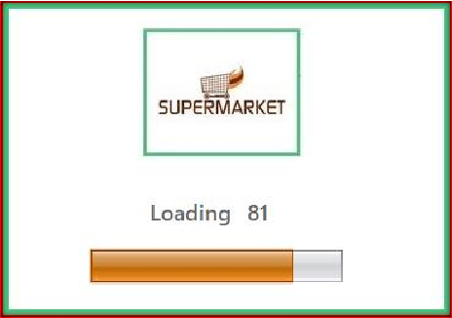

* + 1. **Login Page**

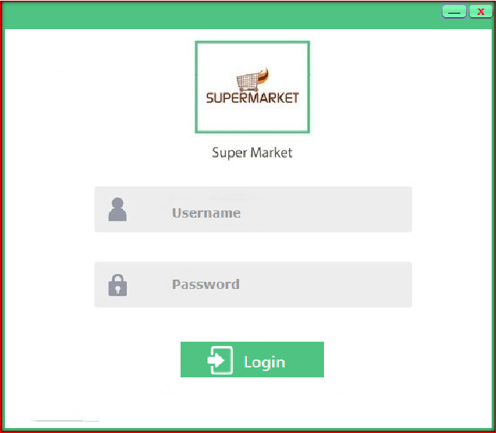

### Admin Panel

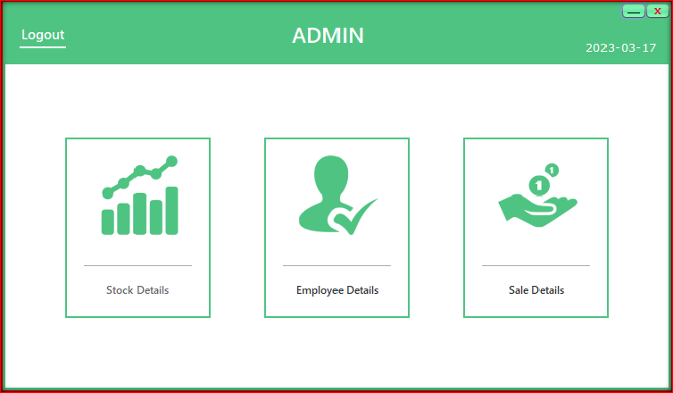

* + 1. **Stock Menu**

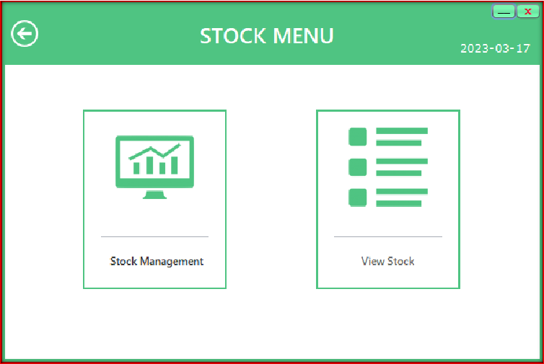

### Stock Management

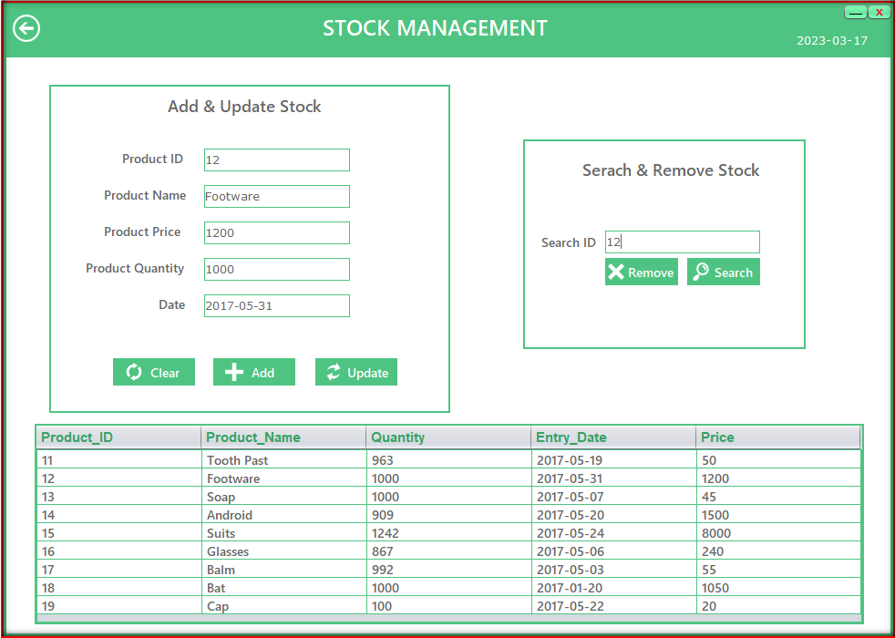

* + 1. **Stock Information**

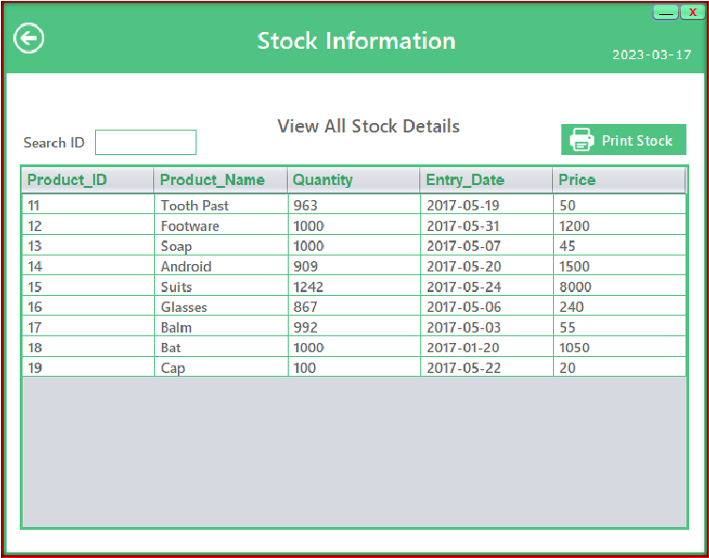

### Employee Management

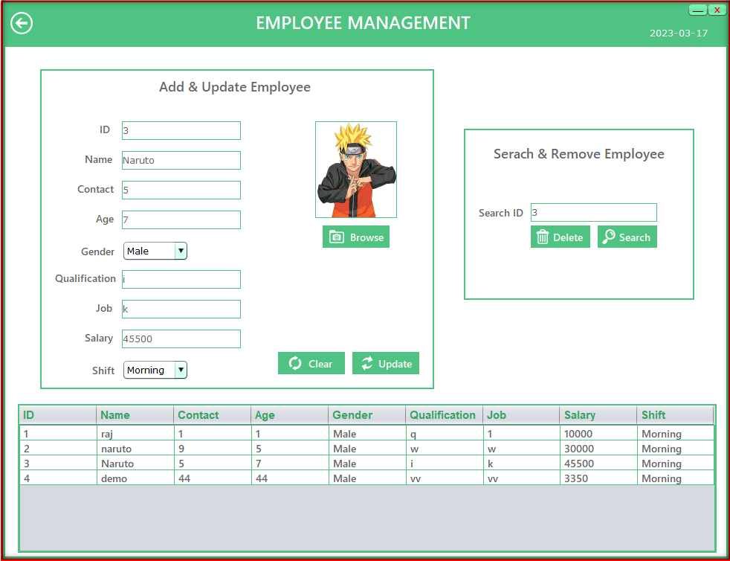

* + 1. **Employee Details**

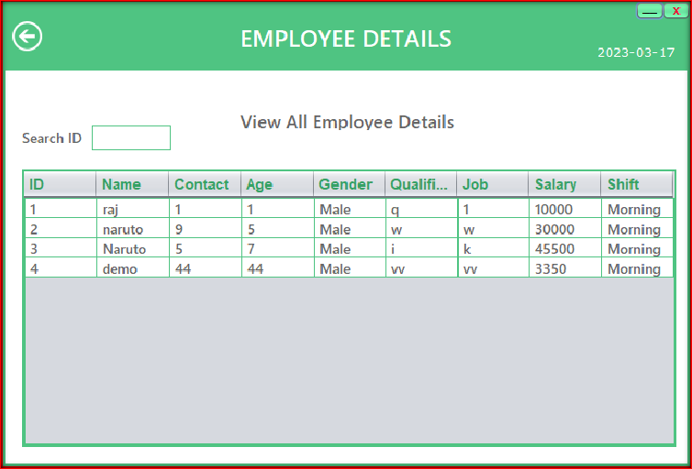

### Salary Status

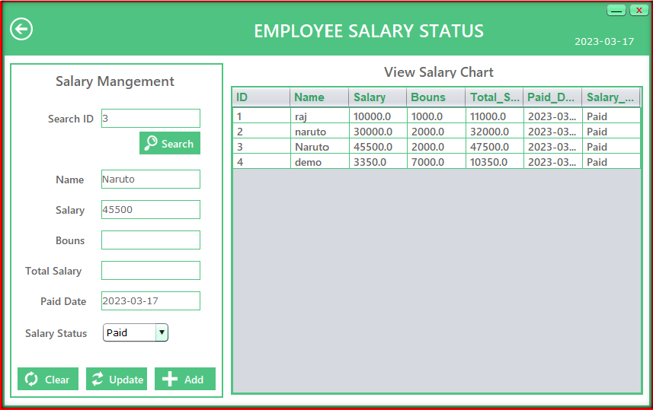

* + 1. **Sales Menu**

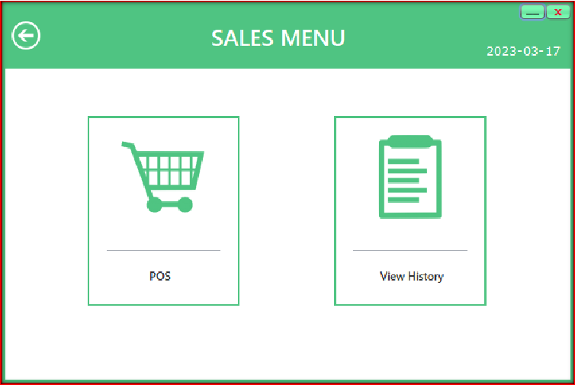

### Point Of Sale (POS)

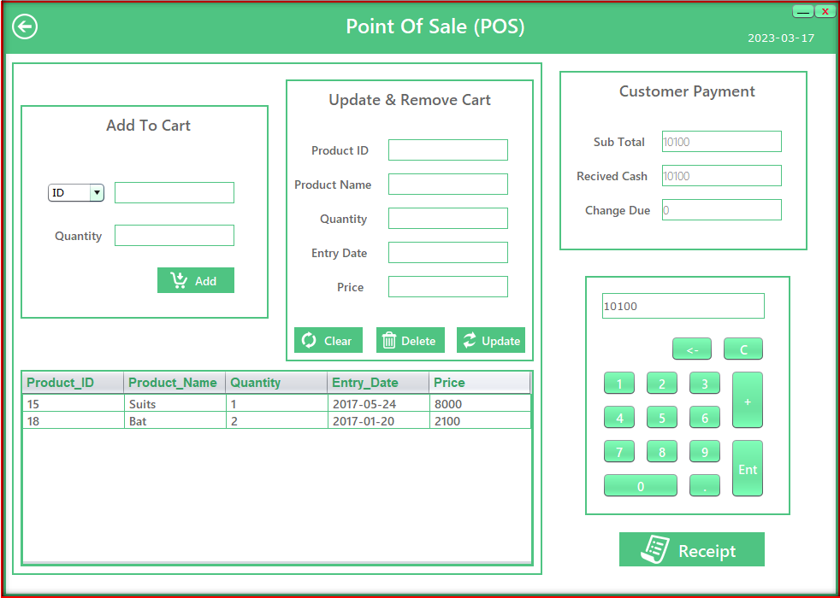

* + 1. **Sales Receipt**

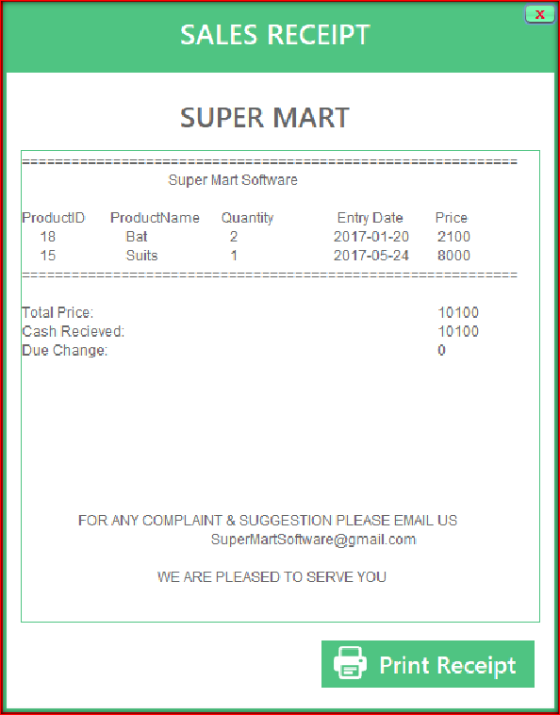

* + 1. **Sales History**

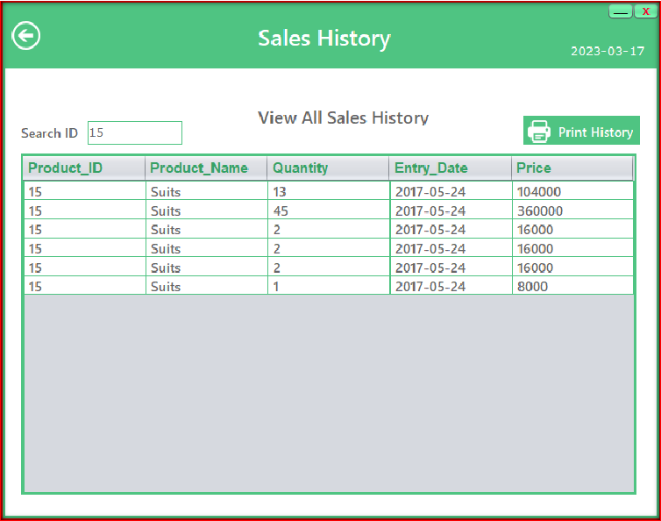

* 1. **Data Dictionary**

|  |  |  |  |  |  |  |  |
| --- | --- | --- | --- | --- | --- | --- | --- |
| **No** | **Data Element** | **Description** | **Data Type** | **Size** | **List of Specific** | **Data Store** | **Remarks** |
| **1** | **Username** | **Admin Name** | **Text** | **20** | **It store admin name** | **Admin Muster** | **It contains admin name** |
| **2** | **Password** | **Admin Password** | **Text** | **20** | **It store admin**  **Password** | **Admin Muster** | **It contains admin password** |
| **3** | **Id** | **Employee Id** | **Number** | **5** | **It store employee**  **number** | **Employee Muster** | **It contains employee Id** |
| **4** | **Name** | **Employee Name** | **Text** | **20** | **It store**  **employee name** | **Employee Muster** | **It contains employee name** |
| **5** | **Contact** | **Employee**  **contact** | **Number** | **10** | **It store**  **employee contact** | **Employee Muster** | **It contain employee contact** |
| **6** | **Age** | **Employee Age** | **Number** | **3** | **It store employee**  **age** | **Employee Muster** | **It contain employee age** |
| **7** | **Gender** | **Employee Gender** | **Text** | **6** | **It store employee**  **gender** | **Employee Muster** | **It contain employee gender** |
| **8** | **Salary** | **Employee Salary** | **Number** | **6** | **It store**  **employee salary** | **Employee Muster** | **It contain employee salary** |
| **9** | **Product_id** | **Product Id** | **Number** | **10** | **It store product Id** | **Product Muster** | **It contain product id** |
| **10** | **Product_ Name** | **Product Name** | **Text** | **20** | **It store product**  **name** | **Product Muster** | **It contain product name** |
| **11** | **Quantity** | **Product Quantity** | **Number** | **5** | **It store product quantity** | **Product Muster** | **It contain product quantity** |

|  |  |  |  |  |  |  |  |
| --- | --- | --- | --- | --- | --- | --- | --- |
| **12** | **Entry_Date** | **Product Entry Date** | **Date** | **-** | **Its store product**  **date** | **Product Muster** | **It contain product date** |
| **13** | **Price** | **Product Price** | **Number** | **6** | **It store product**  **price** | **Product Muster** | **It contain product price** |
| **14** | **Id/ Name** | **Sales Id/ Name** | **Number/ Text** | **20** | **It store Sale Id/**  **Name** | **Sales Muster** | **It contain sales id/ name** |
| **15** | **Quantity** | **Sales Quantity** | **Number** | **5** | **It store**  **sales quantity** | **Sales Muster** | **It contain sales quantity** |

# REPORT TESTING

|  |  |  |  |
| --- | --- | --- | --- |
| **Test Case #** | **Test Case Description** | **Test Data** | **Expected Result** |
| **1** | **Verify that the user is able to log in with valid credentials and is denied access with invalid credentials.** | **Username : admin Password: admin** | **Login should be successful.** |
| **2** | **Search for a product by name and id verify that the correct product details are displayed.** | **Id : 11** | **Product details should be correctly displayed.** |
| **3** | **Add one or more products to the cart and verify that the total amount is updated accordingly.** | **Id:11, Quantity: 5**  **Id:12, Quantity: 4** | **The product details should be properly added and updated accordingly.** |
| **4** | **Remove one or more products from the cart and verify that the total amount is updated.** | **Id:11** | **The product details should be properly remove and updated accordingly.** |
| **5** | **Verify that the software allows the user to add, edit, and delete employee information, including personal details, job title, salary, and performance evaluations.** | **Id: 1, name: om, contact:9865784 565, age: 21,**  **qualification: -, salary:10000** | **The employee details should be properly add, edit and remove accordingly.** |
| **6** | **Verify that the software is able to calculate employee salaries and show the salaries are paid or not.** | **Id:1, name: om, salary: 10000,**  **Bonus: 1200,**  **paid_date: 17** | **The employee salary should be paid accordingly** |

|  |  |  |  |
| --- | --- | --- | --- |
| **7** | **Add and update one or more products from stock and updated their amount and quantity accordingly.** | **Id: 11, name: Tooth Paste, price: 120,**  **quantity: 15** | **The stock details should be properly added and updated accordingly.** |
| **8** | **Search the product from stock and show the details.** | **Id:11** | **The stock details should be display** |
| **9** | **Remove one or more products from the stock and verify that the product details updated.** | **Id: 11** | **The product details from stock should be properly remove accordingly.** |
| **10** | **Verify that the software is able to generate sales receipt , shows the proper amount and details of the product** | **Id: 11, name: Tooth Paste, price: 120,**  **quantity: 1** | **The product details and the sales details with the proper amount should**  **be display properly.** |
| **11** | **Verify that the software is able to**  **generate reports, such as sales reports.** | **Product_id : 11** | **The product**  **details and the sales details**  **should be display properly.** |

**LIMITATIONS AND CONCLUSION**

## Limitations:

* **Compatibility:** The software may have compatibility issues with certain hardware or software configurations, which could affect its performance and usability.
* **Customization:** The software may not be easily customizable to meet the specific needs of individual supermarts, which could limit its usefulness in certain contexts.

## Conclusions:

* Supermart software can streamline and improve the efficiency of supermart operations, resulting in increased customer satisfaction and profitability.
* The success of the software will depend on its ability to meet the needs of supermarts, as well as its ease of use and reliability.
* Continuous improvement and updates are essential to ensure the software remains up- to-date and relevant in a rapidly changing market.
* Overall, the effectiveness of the supermart software will depend on various factors such as user adoption, market demand, and the ability to address the limitations and challenges of the software.

**BIBLIOGRAPHY**

* <https://www.tutorialspoint.com/>
* <https://stackoverflow.com/>
* <https://www.javatpoint.com/>